(1) What is software? What is software engineering?

ans = "Software" is a set of instructions that tell a computer what to do. It is a collection of programs, data, and instructions that tell a computer how to perform specific tasks. System software is responsible for managing the computer's hardware and providing a platform for running application software. Application software is designed to perform specific tasks, such as word processing, video editing, or gaming.

"Software engineering" is the process of designing, developing, testing, and maintaining software. It is a systematic and disciplined approach to software development that aims to create high-quality, reliable, and maintainable software. Software engineering includes a variety of techniques, tools, and methodologies, including requirements analysis, design, testing, and maintenance. software developers can create high-quality, reliable, and maintainable software that meets the needs of its users. Software Engineering is mainly used for large projects based on software systems rather than single programs or applications.

(2) Explain types of software.

ans = Software can be categorized into 6 types:{1}system software {2}middleware software ,{3}application software,{4}programming software,{5}driver software,{6}Embedded software.

1).system software= System software is software that directly operates the computer hardware and provides the basic functionality to the users as well as to the other software to operate smoothly.it is basically operating system.

2).middleware software = Middleware software is a type of software that provides common services and capabilities to applications, such as communication, integration, security, and data management. Middleware software helps developers and operators build and deploy applications more efficiently, by simplifying the connectivity and interoperability between different components and resources in a distributed network

3).system software= Application software is software that is designed to perform specific tasks for users or organizations. It includes general purpose software (such as word processors, spreadsheets, web browsers, etc.), customized software (such as enterprise software, educational software, communication software, etc.), and application suites (such as Microsoft Office, Adobe Creative Suite, etc.)

4).programming software= Programming software is a type of software that helps programmers create other software. Programming software includes tools such as compilers, assemblers, debuggers, interpreters, and integrated development environments (IDEs). These tools help programmers write, test, and debug code for different platforms and languages. Some examples of programming software are Visual Studio code.

5).driver software= Driver software is a type of software that allows your computer to communicate with hardware devices. For example, when you connect a mouse or an external hard drive to your computer, the driver software enables the operating system to recognize and use the device. Without drivers, the devices you connect to your computer wonâ€™t work properly.Some driver software is pre-installed in your computer, while some need to be downloaded and updated manually.

6).Embedded software= Embedded software is a type of software that is written to control machines or devices that are not usually considered as computers, such as cars, phones, robots, appliances, etc. Embedded software is typically specialized for the specific hardware that it runs on and has limited time and memory resources. Embedded software can be very simple or very complex, depending on the application and the device.

(3) What is SDLC? Explain each phase of SDLC.

ans = SDLC stands for Software Development Life Cycle. It is a process that defines the steps involved in developing, testing, and maintaining software. SDLC has six phases: planning, requirement analysis, design, development, testing, and deployment. Here is a brief explanation of each phase:

- Planning: This is the first phase where the project scope, objectives, budget, and schedule are determined. The project team also identifies the risks, assumptions, and constraints of the project.

- Requirement analysis: This is the phase where the customer's needs and expectations are gathered and analyzed. The project team also defines the functional and non-functional requirements of the software. The output of this phase is a document called Software Requirement Specification.

- Design: This is the phase where the software architecture and design are created. The project team also selects the appropriate tools, technologies, and methodologies for the software development. The output of this phase is a document called Software Design Document.

- Development: This is the phase where the actual coding and implementation of the software take place. The project team follows the coding standards and guidelines to ensure the quality and consistency of the software. The output of this phase is the software product or system.

- Testing: This is the phase where the software is verified and validated to ensure that it meets the requirements and specifications. The project team also performs various types of testing such as unit testing, integration testing, system testing, and user acceptance testing. The output of this phase is a document called Software Test Report.

- Deployment: This is the final phase where the software is delivered and installed to the customer or end-user. The project team also provides training, support, and maintenance for the software. The output of this phase is a document called Software Deployment Document.

(4)

ans = DFD stands for Data Flow Diagram. It is a graphical tool that shows the movement of data within a system or a process. It illustrates the sources, destinations, storage, and transformations of data in a system. DFDs are useful for analyzing and designing software systems, as well as understanding the business processes and workflowsÂ¹Â².

A DFD diagram on Flipkart is a visual representation of how data flows through the online shopping platform. It can show the interactions between the customers, sellers, products, orders, payments, and other entities involved in the e-commerce system. A DFD diagram can have different levels of detail, depending on the purpose and scope of the analysis. Here is an example of a DFD diagram on Flipkart

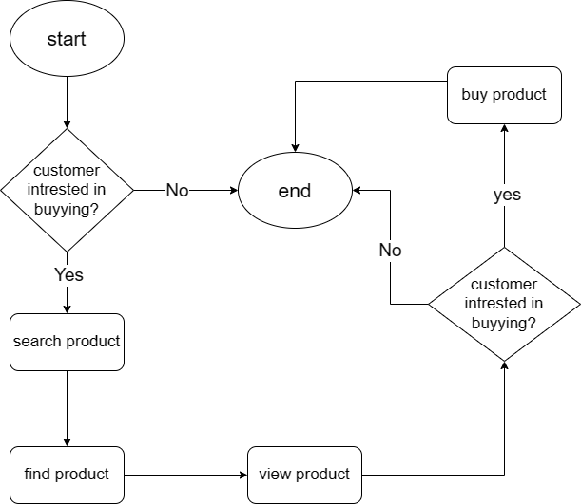

(4) What is Flow chart? Create a flowchart to make addition of two numbers

Ans = A **flowchart** is a type of diagram that represents a workflow or process. It is a visual representation of the sequence of steps and decisions needed to perform a process. Each step in the sequence is noted within a diagram shape. Steps are linked by connecting lines and directional arrows. This allows anyone to view the flowchart and logically follow theprocess 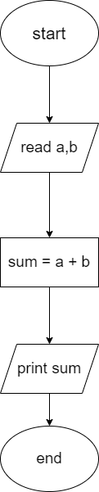from beginning to end.

(6) What is Use case Diagram? Create a use-case on bill payment on paytm.

Ana = A **Use Case Diagram** is a type of Unified Modeling Language (UML) diagram that represents the interaction between actors (users or external systems) and a system under consideration to accomplish specific goals. It provides a high-level view of the system’s functionality by illustrating the various ways users can interact with it.

Use Case Diagram for Bill Payment on Paytm

In this diagram, there are two primary actors: User and Paytm. The user can perform the following use cases:

* Login: The user logs in to their Paytm account.
* ViewBill: The user views their bill details.
* Make Payment: The user makes a payment using one of the available payment methods.
* Logout: The user logs out of their Paytm account.

Paytm can perform the following use cases:

* Verify Payment: Paytm verifies the payment made by the user.